Freefall W.S.

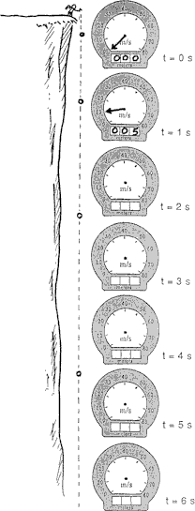
1. A rock dropped from the top of a cliff picks up speed as it falls. Pretend that a speedometer and odometer are attached to the rock to show readings of speed and distance at 1-second intervals. Both speed and distance are zero at time = zero (see sketch). Note that after falling 1 second the speed reading is 10 m/sec and the distance fallen is 5 m. The readings for succeeding seconds of fall are not shown and are left for you to complete. So record the position of the speedometer pointer and write in the correct odometer reading for each time.

To simplify your calculations, you may use g = 10 m/sec2 and neglect air resistance.

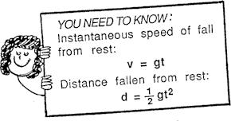

sec

- sec
speed (m/sec) | distance (m)

sec

- sec

sec

  - The speedometer reading increases by the same amount, m/sec, each second.

  - This increase in speed per second is called .

  - The distance fallen increases as the square of the .
Refer to the following information for the next four questions.

2. Suppose that it takes a total of 7 seconds for the rock to reach the base of the cliff.
- Its speed at impact is m/sec.

- The total distance fallen is m.

- Its acceleration of fall just before impact is m/s2.

- However, the distance that it fell during only the 7th second was m.
- Aunt Minnie gives you $10 per second for 4 seconds.

  - How much money do you have after 4 seconds?

  - A ball dropped from rest picks up speed at 10 m/sec per second. After it falls for 4 seconds, how fast is it going?

  - You have $20, and Uncle Harry gives you $10 each second for 3 seconds. How much money do you have after 3 seconds?

  - A ball is thrown straight down with an initial speed of 20 m/sec. After 3 seconds, how fast is it going?

  - You have $50 and you pay Aunt Minnie $10/second. When will your money run out?

Refer to the following information for the next five questions:

- You shoot an arrow straight up at 60 m/sec.

  - When will it run out of speed?

  - Speed is one thing; distance another. Where is the arrow you shot up at 60 m/sec when it runs out of speed?

  - What will its speed be 6 seconds after you shoot it?

  - What will its speed be 7 seconds after you shoot it?

  - How high above the ground will the arrow be 7 seconds after being shot up at 60 m/sec?

Refer to the following information for the next four questions:

- Aunt Minnie drops a penny into a wishing well and it falls for 4 seconds before hitting the water.
- How fast is it going when it hits?

- What is the penny's average speed during its 4-second drop?

- How far down is the water surface?

- Aunt Minnie didn't get her wish, so she goes to a deeper wishing well and throws a penny straight down into it at 10 m/s. How far does this penny go in 4 seconds?

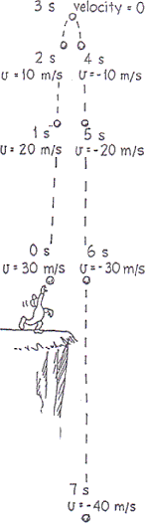
- To simplify your calculations, you assume negligible air resistance and use g = 10 m/sec2.

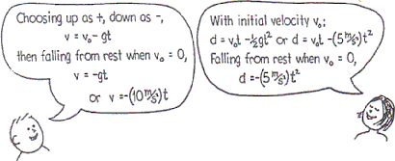
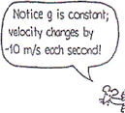

Table 1 shows the data for the figure for t = 0 to t = 8 seconds. Table 2 is for a greater initial velocity, vo = 50 m/sec. All displacements are referenced from the starting point.

Table 1 |  |  | Table 2
time (sec) | velocity (m/sec) | displacement (m) | velocity (m/sec) | displacement (m)
0 | 30 | 0 | 50 | 0

1

2

3

4

5

6

7

8
Refer to the following information for the next five questions.

7. A rock dropped from a 20 meter bridge falls into the river below.
- Which kinematics variables are stated in this problem?

v o  initial velocity | v f  final velocity | a acceleration | s displacement | t  time interval

- At what velocity does it strike the water?

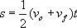
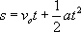
- Which kinematics equation did you use to solve this problem?

- Based on the ORIGINAL givens, which equation would you now use to determine how much time it takes for the rock to reach the water?

- How much time did the rock take to reach the water?

Refer to the following information for the next two questions:

- The rock is now tossed upwards at 6 m/sec from a 20 meter bridge falls into the river below.

  - At what velocity does it strike the water?

  - How much time did the rock take to reach the water?

Refer to the following information for the next two questions:

- The rock is now thrown downward at 6 m/s from a 20 meter bridge falls into the river.

  - At what velocity does it strike the water?

  - How much time did the rock take to reach the water?
Refer to the following information for the next five questions.

10. A rock is thrown straight up into the air and returns to its original release position after 4 seconds.
- Which kinematics variables are stated in this problem?

v o  a. The initial velocity | v f  final velocity | a  acceleration | s  displacement | t  time interval

- If you want to determine how fast the rock was released, which kinematics equation should you use?

- How fast was it released?

- Which equation(s) could you now use to determine how high it rose up into the air?

- How high did it rise?

Refer to the following information for the next two questions:
- An empty can of paint falls from the top of a 6 foot (1.8 m) tall ladder.

  - How fast will it hit the floor?

  - How much time does it spend in the air before it hits the ground?
Refer to the following information for the next two questions.

12. A stone is dropped from the top of an overhang into the river below.
a. If it takes 4 seconds for it to strike the water, from what height was it released?

How fast was it traveling when it struck the water?

Refer to the following information for the next two questions:

- A bouncing superball rises to a height of 1.5 meters before returning to the ground.
  - How fast was it traveling when it first left the floor?

  - How much total time does it spend in the air before it once again hits the floor?
Refer to the following information for the next three questions.

14. A juggler tosses a ball upwards at 5 m/sec while sitting atop a 3.5-meter tall unicycle.
- How high does the ball rise into the air above the release position?

- If the juggler fails to catch the ball, how much total time will it spend in the air before hitting the floor at the base of the unicycle?

- How fast will the ball be traveling when it strikes the floor?

Refer to the following information for the next two questions:

- A 2-meter tall basketball player trapped almost under the net tosses the ball in a last second attempt to make a goal.

  - How fast was the ball thrown if it just slides into the 3-meter basket as it reaches the apex of its trajectory? Assume the player released the ball just as his hands were level with the top of his head.

  - How much time did the ball travel through the air before sliding into the basket?

Refer to the following information for the next two questions.

16. When rising to spike a ball in a volleyball game, a player jumps vertically 1.0 meters off the floor.
- How much total time does he spend in the air, assuming he lands in the same position from which he left the ground?

- At what velocity did he hit the ground at the end of the jump?

Refer to the following information for the next three questions:

- Three students are standing side-by-side next to the railing on a fifth floor balcony. Simultaneously, the three students release their pennies:
  - One student proceeds to drop a penny to the ground below.
  - The second student tosses his penny straight downwards at 15 m/sec, while
  - The third student tosses his penny straight upwards at 15 m/sec.
a. Which penny or pennies strike(s) the ground first?

- Which penny or pennies strike(s) the ground last?

- Which penny or pennies strike(s) the ground with the greatest final velocity?

Refer to the following information for the next four questions.

18. A student, while packing up his book bag that is located near the edge of a lab table 90-cm tall, accidentally drops his pencil on the floor.
- Which kinematics variables are stated in this problem?

v o  initial velocity | v f  final velocity | a  acceleration | s  displacement | t  time interval

- With what velocity did the pencil hit the floor?

- How much time does it take the pencil to fall and strike the floor?

- If the room temperature is 25 ºC, how much total time passed between when he lost his grip on the pencil and when he hears the sound of it hitting the floor?

Refer to the following information for the next three questions:
- While holding his rifle at shoulder-level, a 1.8 meter-tall hunter accidently discharges it straight up into the air.
  - If the bullet exits the barrel of the rifle at 200 m/sec how many seconds does the hunter have to "step aside" to avoid being hit by the descending bullet?

  - How high did the bullet rise in the air before it starting falling back down to earth?

  - If he does not move fast enough, at what velocity would the descending bullet strike his shoulder?

Refer to the following information for the next three questions.

20. Two students are tossing a set of keys from one to the other. The first student (who initially has the keys) is 1.8 meters tall and is standing on the ground 4 meters below the second student who is on a catwalk.

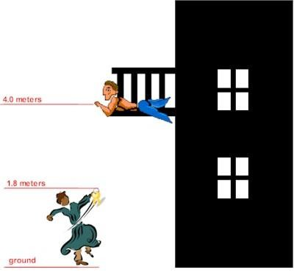

The student on the ground tosses the keys upward, releasing them exactly as his hand reaches the top of his head, with just the right velocity so that their apex coincides with the second student's outreached hand.
- Which kinematics variables are stated in this problem?

v o  initial velocity | v f  final velocity | a  acceleration | s  displacement | t  time interval

- How fast were the keys tossed?

- How much time did the keys spend in the air?

Refer to the following information for the next three questions:
- Suppose that the student on the balcony was distracted and failed to catch the keys and they fall back down to the ground.
- With what velocity will they strike the grass at the feet of the first student?

- True or False. The keys spent the same amount of time falling to the ground as they spent rising towards the balcony.

True | False

- True or False. The keys struck the ground at the same speed as they were originally tossed upwards by the first student.

True | False

- A motorist wishes to travel 40 kilometers at an average speed of 40 km/hr. During the first 20 kilometers, an average speed of 40 km/hr is maintained. During the next 10 kilometers, however, the motorist goofs off and averages only 20 km/hr. To drive the last 10 kilometers and average 40 km/hr, the motorist must drive
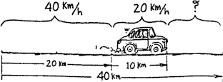

- 60 km/hr
- 80 km/hr
- 90 km/hr
- faster than the speed of light
- When the 10 km/hr bikes are 20 km apart, a bee begins flying from one wheel to the other at a steady speed of 30 km/hr. When it gets to the wheel it abruptly turns around and flies back to touch the first wheel, then turns around and keeps repeating the back-and-forth trip until the bikes meet, and squish!
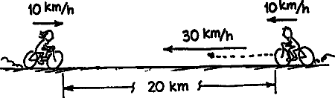

How many kilometers did the bee travel in its total back-and forth trips?

- REVIEW: Consider two satellites in orbit about a star (like our sun). If one satellite is twice as far from the star as the other, but both satellites are attracted to the star with the same gravitational force, how do the masses of the satellites compare?
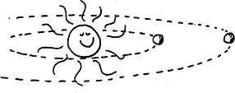

- What will be the acceleration of a rock thrown straight upward at the moment it reaches the tippity-top of its trajectory?

- If you release a ball inside a freely-falling elevator it stays in front of you instead of "falling to the floor" because you, the ball, and the elevator are all accelerating downward at the same acceleration, g. If you similarly release a helium-filled balloon, the balloon will

  - also stay in front of you
  - press against the ceiling
  - press against the floor

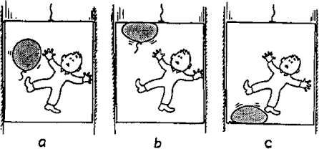

- REVIEW: What is the voltage across the terminals of a 23 Ω resistor that has 0.065 A of current flowing through it?

A. 0.0028 V | B. 0.097 V | C. 1.5 V | D. 350 V
- REVIEW: Which of the following actions would increase the current through a circuit component?

A. decreasing the power in the component
B. increasing the resistance of the component
C. increasing the voltage across the component
D. placing another identical component in series in the circuit
- REV.: A star suddenly explodes. Which of the following types of waves reach Earth’s surface?

A. light only | B. sound only | C. sound followed by light | D. light followed by sound

